Go back to first step and re do sandwich

Yes

No

Then add a layer of lettuce. Finally drizzle some oil and vinegar on top of the lettuce. Once completed, add the other half of bread on top.

Grab a plate. Then lay one of the halves of bread down onto the plate. Add the ham, salami, and provolone to the bread first. Each meat and the cheese should be at least 2 layers.

The objective is to create a ham, salami, provolone, lettuce, and oil and vinegar sandwich for lunch today

My Favorite Sandwich

Ham, Salami, Provolone, Lettuce, and Oil and Vinegar on Italian bread

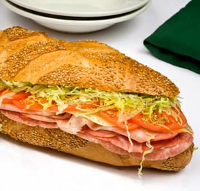

¼ pound of Black Bear Ham, Salami and provolone, shredded lettuce, and oil and vinegar

Make sure the final product met its goal

If goal is met, you may know eat the sandwich. Enjoy!

Final Product

The goal is a neat, well put together, delicious sandwich to fill up my appetite for lunch

Identify Objective and goal

A piece of fresh warm Italian bread from the bakery down the street

Gather/Buy Ingredients

Construct the sandwich

Jake Lorah